 | Student Name _______________________  Eastern Goldfields College  Mathematics Essentials 2018  Investigation 2 – Room Renovation
DUE DATE: _____________________________ TOTAL MARKS: 35
This investigation is a take-home task worth 2.5%
You have been assigned ROOM 1 and the dimensions of the room are shown below.

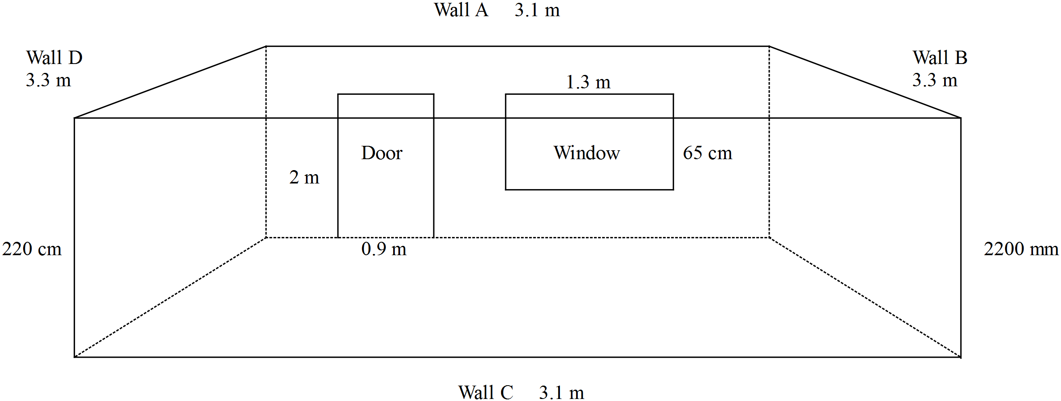

You must calculate the total cost of the room renovation by completing the questions given.

Question 1 Calculate the area of the door. (2 marks)

Question 2 Calculate the area of the window. (2 marks)

Question 3 a) Calculate the area of each wall in the room. To complete this question:
- Draw a diagram of each wall, including its dimensions. (2 marks)
- Show all your working out so that your answer can be checked. (8 marks)
- Be careful with Wall A – do not include the door and window in your answer.

b) What is the total area of the walls? (1 mark)

Question 4 The frame around the door is wooden.
- What length is needed to replace the frame around the door? (2 marks)

- If you have been quoted $11 per metre, what would it cost to buy the wood for the frame? (2 mark)

Question 5 Skirting board is a decorative edge that goes around the bottom of the room, where the wall meets the floor.
- What length of skirting board is needed to go around the room? (2 marks)

- What will this cost at $4.80 per metre? (1 mark)

Question 6 You need to paint three walls in your room and wallpaper the fourth one. This will be a feature wall. 4L of Taubmans Endure paint costs $68.50 and covers 64 m². 2L of Dulux Wash & Wear paint costs $53.50 and covers 32 m². Wallpaper is sold in rolls 52 cm wide and 10m long and costs $57.67 each
- How much paint will you need to do two coats? (2 marks)

- Calculate the cost of paint for the room. (1 mark)

- Calculate the cost of wallpaper for your room. (4 marks)

Question 7 The renovation for this room will be the new frame around the door, the skirting board, two coats of paint for the room and the wall paper. What is the total cost of the room renovation?
(1 marks)

Question 8 Americans use imperial measures, for example feet and inches. (5 marks)
a) What is an inch in centimetres? One inch = _______________ cm

b) What is the height of the door in inches?

c) Calculate the approximate area of the wallpaper in square feet.

END OF APPLICATION

